About The Algorithm Solution Of A Planned Channel Problem

Igor I. Potapov

Computing center FEB RAS, 65 Kim U Chena Street, Khabarovsk City, 680000, Russian Federation

Abstract
The paper formulates a mathematical model for the problem of bottom deformations. Based on the Petrov-Galerkin method, a method is proposed and an algorithm for solving the problem is developed. Examples of solving the problem in a rectangular region with different orientations of the shear stress fields are given.

Keywords
Bed load transport model, Sediment transport mechanisms, finite element method.

- Geometric dependencies.

Let us give exact formulas for the local characteristics of the bottom surface, not considering the slope of the bottom surface to be small. Let 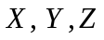 be a fixed Cartesian coordinate system with axis  directed vertically upward and unit vectors 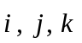.

The bottom surface in this coordinate system is defined by Equation 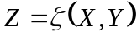, where 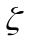 is a sufficiently smooth function of the variables . The normal vector 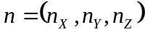 to the bottom surface has the components
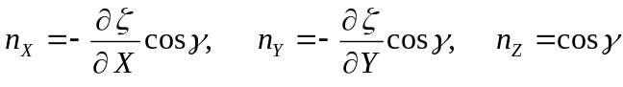, (1)
where is the angle between the normal to the bottom and the axis . The trigonometric functions of the angle have the form
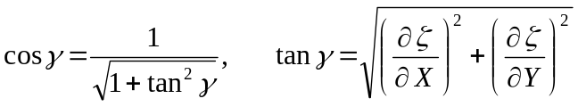. (2)
The projection of the unit vector directed vertically upwards onto the tangent plane of surface 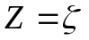is called the slope vector (Fig. 1), which can be decomposed into vectors and : 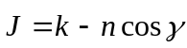. From here it is easy to write down its components along the axes 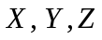and determine the length 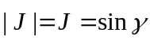.
Along with the absolute coordinate system, we introduce the local curvilinear orthogonal coordinate system 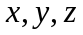. The axis is orthogonal to the tangent plane to the surface 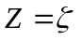, the axis is the internal coordinates of this surface.
In the local coordinate system, the bottom surface is defined by Equation 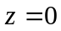. The slope vector in the local coordinate system has components 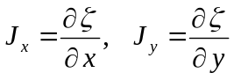 or, in vector form, 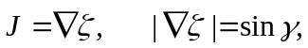 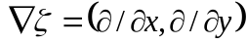.
The tangent plane perpendicular to the normal (1) of the bottom surface , at point 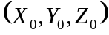 is defined as
(3)
The projection of the radius of the bottom velocity vector 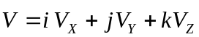 onto the tangent plane (3) defined by the normal (1): is determined by the expression 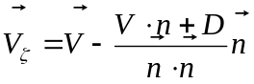, or
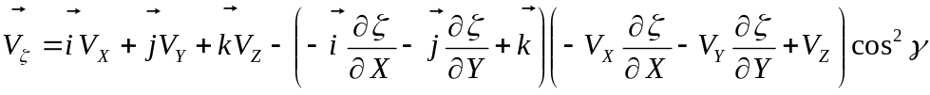, (4)
which makes it possible to obtain the direction of the unit vectors of the local coordinate system for axes and .
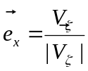 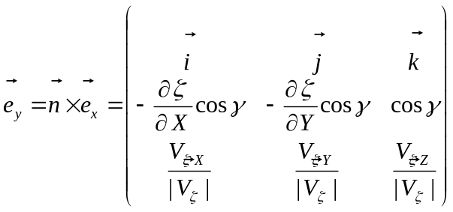. (5)
At small slopes of the bottom
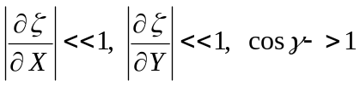, 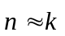 and 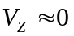 , (6)
get
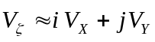, 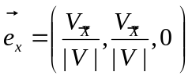, (7)
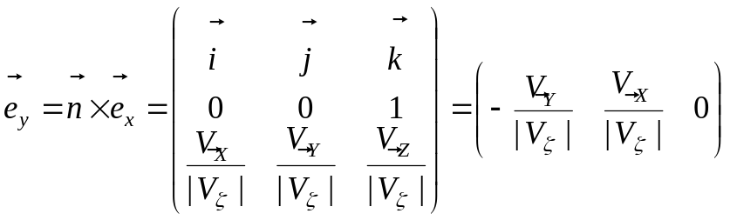 (8)
Therefore, under the assumption of small slopes of the bottom (5), we obtain the following matrix transformation
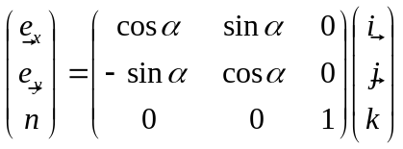, 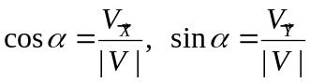, (9)
which we will use in this work.

2. Governing Equations
Let us consider the problem of the evolution of the bottom surface 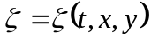in a channel with a sandy bottom. The mathematical model of the problem is not closed and requires the determination of the bottom shear stresses 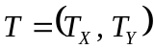 and bottom pressure determined from the solution of the external problem of hydrodynamics.
The calculation of the change in the bottom surface is carried out using the Exner equation

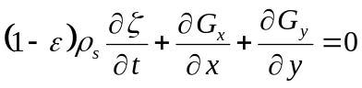 (10)
and equations of the flow rate of entrained sediment [1]
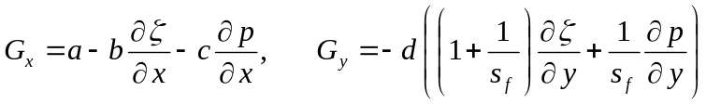 (11)
where 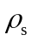 is the density of sand, 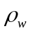 is the density of the liquid, is the porosity of the bottom material, 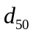 is the average diameter of bottom particles,  is the concentration of entrained particles in the active bottom layer, is the angle of internal friction of sediments; - Karman coefficient for water-soil mixture 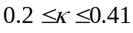,
,
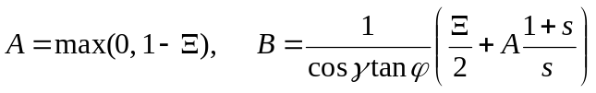,
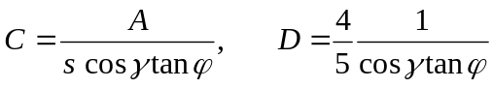,
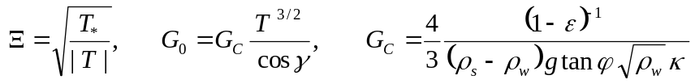,
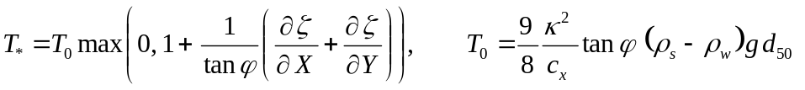,
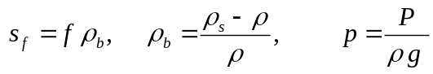.

3. Bringing the equations of the problem into a Cartesian coordinate system
According to definition (9), the local coordinate system 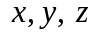 is related to the Cartesian absolute coordinate system 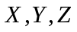through the velocity field of the hydrodynamic flow 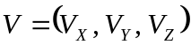
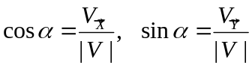 (12)
Assuming that conditions 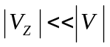, 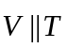, equations (12) are valid in the bottom layer, the velocity vector 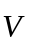can be replaced by the vector of bottom shear stresses 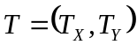
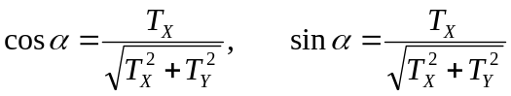, (13)
from which follows the condition 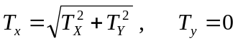, which is necessary [1] for deriving equations (11). Using expressions (9), (13), we obtain
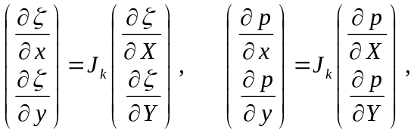 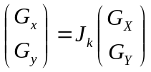, (14)
where 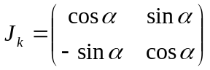 is the Jacobi matrix.
Taking into account (14), expressions (11) in the Cartesian coordinate system take the form
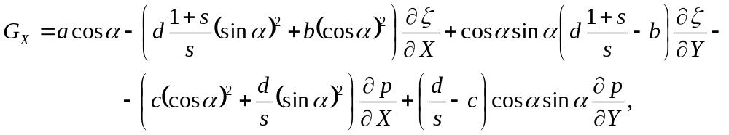
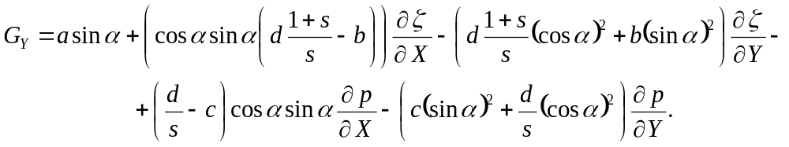
Substituting these equations, into the Exner equation (10) we obtain the equation of bottom deformations of the form
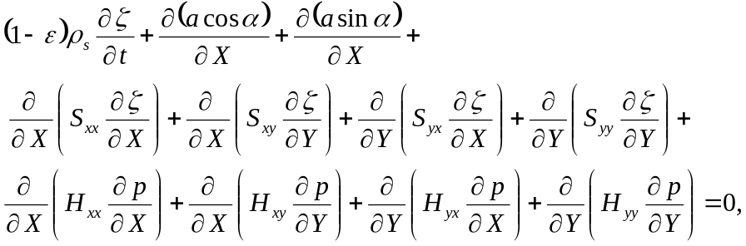

where 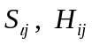- components of gravity-diffusion and pressure tensors, determined by the formulas
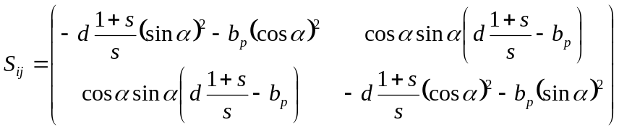,
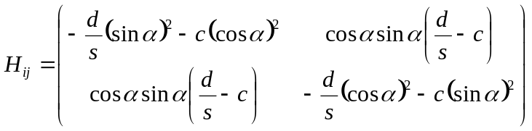.

4. Formulation of the deformable bottom problem
Assuming that the solution of the external hydrodynamic part of the problem allows us to determine the vector of bottom shear stresses 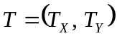and bottom pressure acting on the bottom of the channel  bounded by the contour 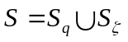, we formulate the planned problem of changing the bottom surface under the action of water flowing through it, which includes :
- equation of bottom deformations
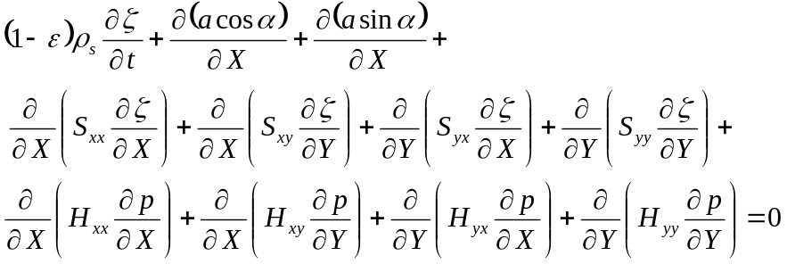 (15)
initial conditions
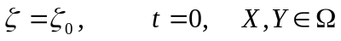. (16)
and boundary conditions
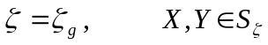, (17)
, (18)
where is the specific discharge of sediment across the border 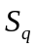. 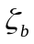- bottom marks at the border 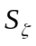, 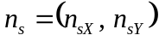 - normal to the border .

5. Obtaining a discrete analog
Consider a weak variational Galerkin formulation for problem (15) - (18) with a set of test functions 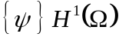 in the following form.
Find an unknown function 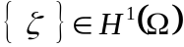 such that:
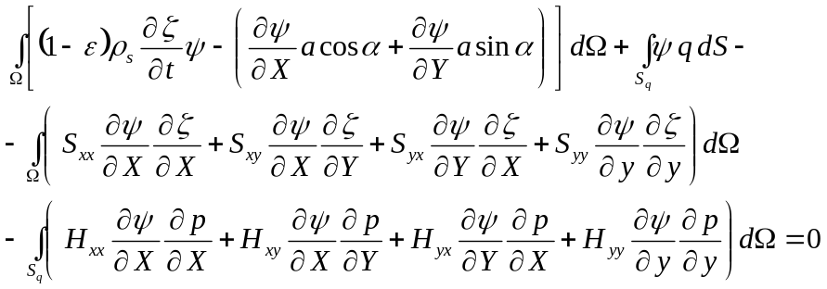 (19)
Integral identity (19) must satisfy conditions (16), (17).
Using the finite element method in the formulation of Petrov - Galerkin. We divide the computational domain into finite elements 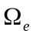, 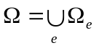. We introduce an approximation of the bottom surface on a finite element
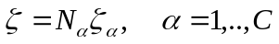, (20)
where 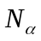 are the shape functions of the finite element, 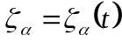 are the bottom elevation values ​​at the nodes of the finite element,  is the number of nodes on the finite element. We assume that approximation on time layers () is linear and for it the relations
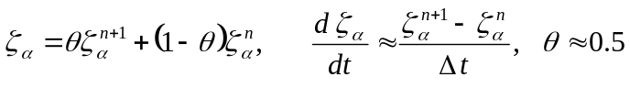. (21)
Choosing as weight functions , on a finite element, functions of the form , taking into account (20) - (21), from integral identity (19), a finite element recurrent discrete analogue of problem (19), (16), (17)
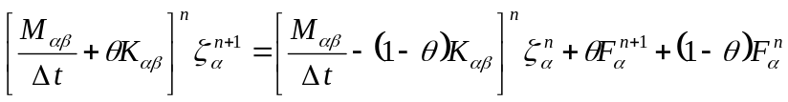, (22)
Where
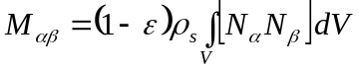, (23)
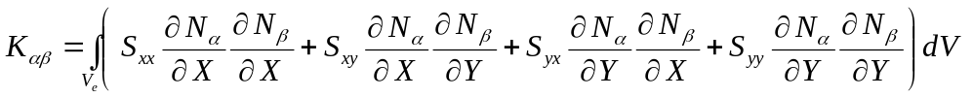 (24)

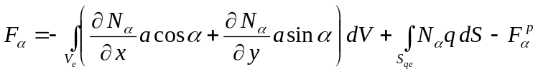. (25)
.
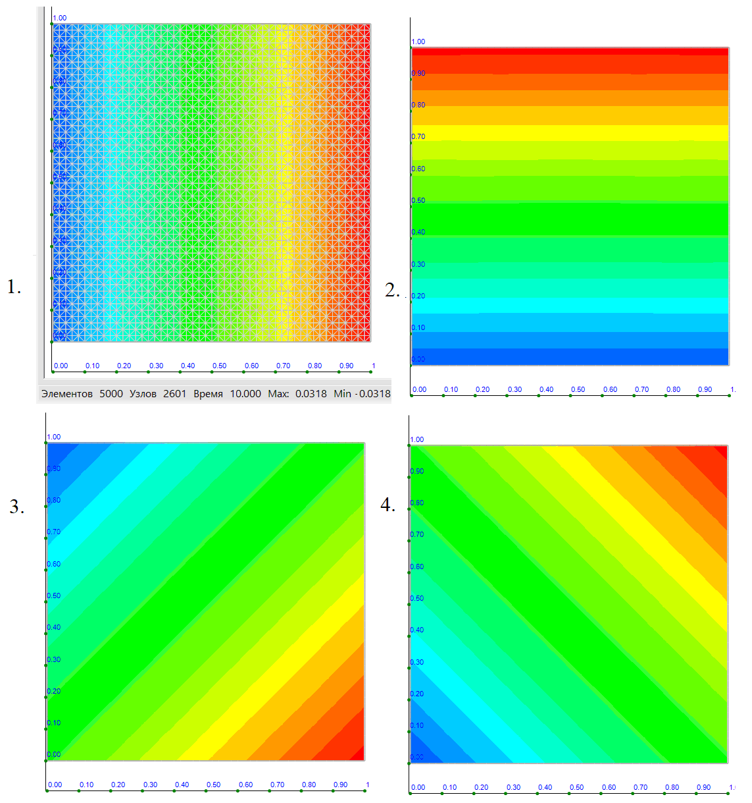
Fig. 1. Bottom surface erosion schemes

6. Examples of solving test problems.
Let us consider examples of calculating bottom changes in a square area with edges of unit length. Homogeneous boundary conditions are specified on the contour of the region 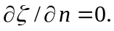 Figure 1 shows the results of bottom deformations obtained at time 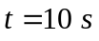 for the following variants of stress fields
.
From the results obtained (fields 1-4), one can see the spatial isotropy of the obtained solutions. The calculations performed in the quasi-one-dimensional approximation show good agreement of the obtained solutions with the known experimental data [1] from which one can draw a conclusion about the applicability of the proposed method and calculation algorithm for modeling arbitrary planned tasks of channel deformations.

This work was carried out with the partial support of the RFBR grant No. 21-57-53019.

Literature
[1]. Petrov A.G., Potapov I.I. Selected Sections of Channel Dynamics. - Moscow.: Lenand, (2019). 244 p.

VI International Conference Information Technologies and High-Performance Computing (ITHPC-2021), September 14–16, 2021, Khabarovsk, Russia EMAIL: potapov2i@gmail.com ORCID: https://orcid.org/0000-0002-3323-2727 ©️ 2021 Copyright for this paper by its authors. Use permitted under Creative Commons License Attribution 4.0 International (CC BY 4.0). CEUR Workshop Proceedings (CEUR-WS.org)

